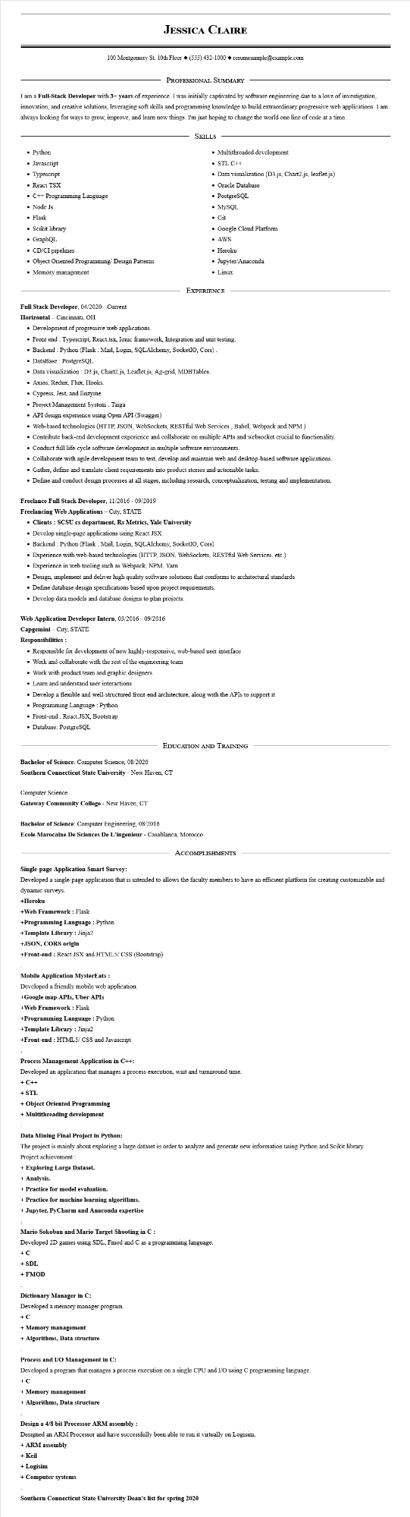
JESSICA CLAIRE
100 Montgomery St. 10th Floor (555) 432-1000◆ resumesample@example.com
PROFESSIONAL SUMMARY
I am a Full-Stack Developer with 3+ years of experience. I was initially captivated by software engineering due to a love of investigation, innovation, and creative solutions, leveraging soft skills and programming knowledge to build extraordinary progressive web applications. I am always looking for ways to grow, improve, and learn new things. I'm just hoping to change the world one line of code at a time.
SKILLS
• Python
• Javascript
• Typescript
• React TSX
• C++ Programming Language
• Node Js
• Flask
• Scikit library
• GraphQL
• CD/CI pipelines
• Object Oriented Programming/Design Patterns
• Memory management
• Multithreaded development
• STL C++
• Data visualization (D3.js, Chart2.js, leaflet.js)
• Oracle Database
• PostgreSQL
• MySQL
• Git
• Google Cloud Platform
• AWS
• Heroku
• Jupyter/Anaconda
Linux
EXPERIENCE
Full Stack Developer, 04/2020 - Current
Horizontal - Cincinnati, OH
• Development of progressive web applications.
• Front end : Typescript, React.tsx, Ionic framework, Integration and unit testing.
• Backend: Python (Flask : Mail, Login, SQLAlchemy, SocketIO, Cors).
• DataBase: PostgreSQL
• Data visualization: D3.js, Chart2.js, Leaflet.js, Ag-grid, MDBTables.
Axios, Redux, Flux, Hooks.
• Cypress, Jest, and Enzyme.
• Project Management System: Taiga
• API design experience using Open API (Swagger)
• Web-based technologies (HTTP, JSON, WebSockets, RESTful Web Services, Babel, Webpack and NPM)
• Contribute back-end development experience and collaborate on multiple APIs and websocket crucial to functionality.
• Conduct full life-cycle software development in multiple software environments.
• Collaborate with agile development team to test, develop and maintain web and desktop-based software applications.
• Gather, define and translate client requirements into product stories and actionable tasks.
• Define and conduct design processes at all stages, including research, conceptualization, testing and implementation.
Freelance Full Stack Developer, 11/2016 - 09/2019
Freelancing Web Applications - City, STATE
• Clients: SCSU cs department, Rs Metrics, Yale University
• Develop single-page applications using React JSX
• Backend: Python (Flask : Mail, Login, SQLAlchemy, SocketIO, Cors)
• Experience with web-based technologies (HTTP, JSON, WebSockets, RESTful Web Services, etc.)
• Experience in web tooling such as Webpack, NPM, Yarn
• Design, implement and deliver high quality software solutions that conforms to architectural standards
• Define database design specifications based upon project requirements.
• Develop data models and database designs to plan projects.
Web Application Developer Intern, 03/2016 - 09/2016
Capgemini - City, STATE
Responsibilities:
• Responsible for development of new highly-responsive, web-based user interface
• Work and collaborate with the rest of the engineering team
• Work with product team and graphic designers
• Learn and understand user interactions
• Develop a flexible and well-structured front-end architecture, along with the APIs to support it
• Programming Language: Python
• Front-end React.JSX, Bootstrap
• Database: PostgreSQL
EDUCATION AND TRAINING
Bachelor of Science: Computer Science, 08/2020
Southern Connecticut State University - New Haven, CT
Computer Science
Gateway Community College - New Haven, CT
Bachelor of Science: Computer Engineering, 08/2016
Ecole Marocaine De Sciences De L'ingenieur - Casablanca, Morocco
ACCOMPLISHMENTS
Single-page Application Smart Survey:
Developed a single-page application that is intended to allows the faculty members to have an efficient platform for creating customizable and dynamic surveys.
+Heroku
+Web Framework : Flask
+Programming Language : Python
+Template Library: Jinja2
+JSON, CORS origin
+Front-end : React JSX and HTML5/CSS (Bootstrap)
Mobile Application MysterEats:
Developed a friendly mobile web application.
+Google map APIs, Uber APIs
+Web Framework: Flask
+Programming Language: Python
+Template Library: Jinja2
+Front-end : HTML5/CSS and Javascript
Process Management Application in C++:
Developed an application that manages a process execution, wait and turnaround time.
+ C++
+ STL
+ Object Oriented Programming
+ Multithreading development
Data Mining Final Project in Python:
The project is mainly about exploring a large dataset in order to analyze and generate new information using Python and Scikit library.
Project achievement:
+ Exploring Large Dataset.
+ Analysis.
+ Practice for model evaluation.
+ Practice for machine learning algorithms.
+ Jupyter, PyCharm and Anaconda expertise
Mario Sokoban and Mario Target Shooting in C:
Developed 2D games using SDL, Fmod and C as a programming language.
+ C
+ SDL
+ FMOD
Dictionary Manager in C:
Developed a memory manager program.
+ C
+ Memory management
+ Algorithms, Data structure
Process and I/O Management in C:
Developed a program that manages a process execution on a single CPU and I/O using C programming language.
+C
+ Memory management
+ Algorithms, Data structure
Design a 4/8 bit Processor ARM assembly:
Designed an ARM Processor and have successfully been able to run it virtually on Logisim.
+ ARM assembly
+ Keil
+ Logisim
+ Computer systems
Southern Connecticut State University Dean's list for spring 2020

